**LAB-1**

**1.Develop a Java program that prints all real solutions to the quadratic equation ax2 +bx+c = 0.**

**Read in a, b, c and use the quadratic formula. If the discriminate b2-4ac is negative, display a message stating that there are no real solutions**.

**OBSERVATION:**

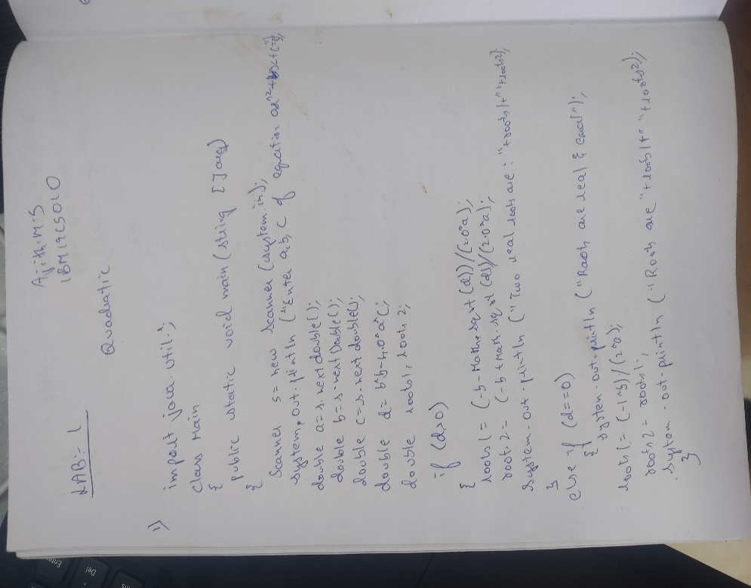

**OUTPUT:** 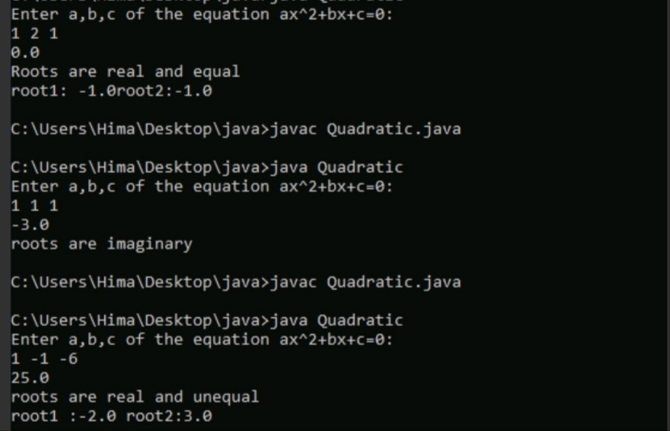

**LAB-2**

**2. Develop a Java program to create a class Student with members usn, name, an array**

**credits and an array marks. Include methods to accept and display details and a method to**

**calculate SGPA of a student**.

OBSERVATION:

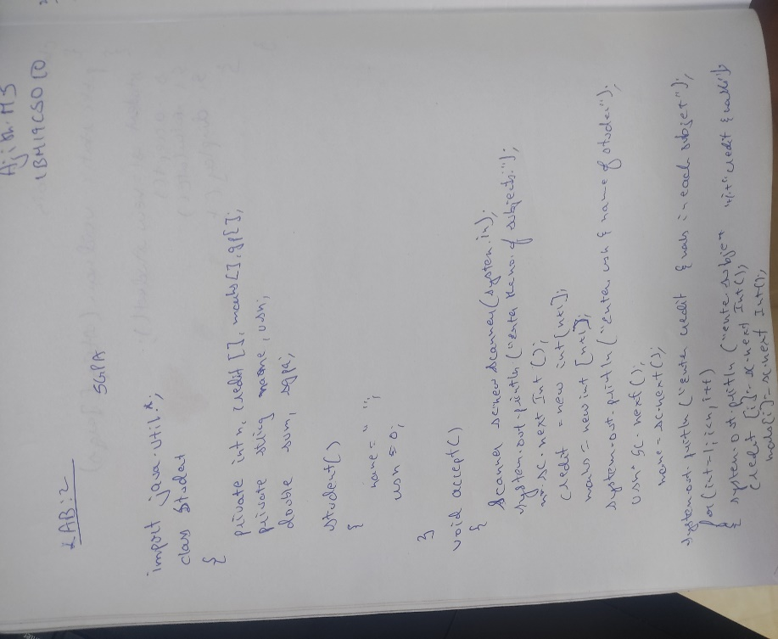 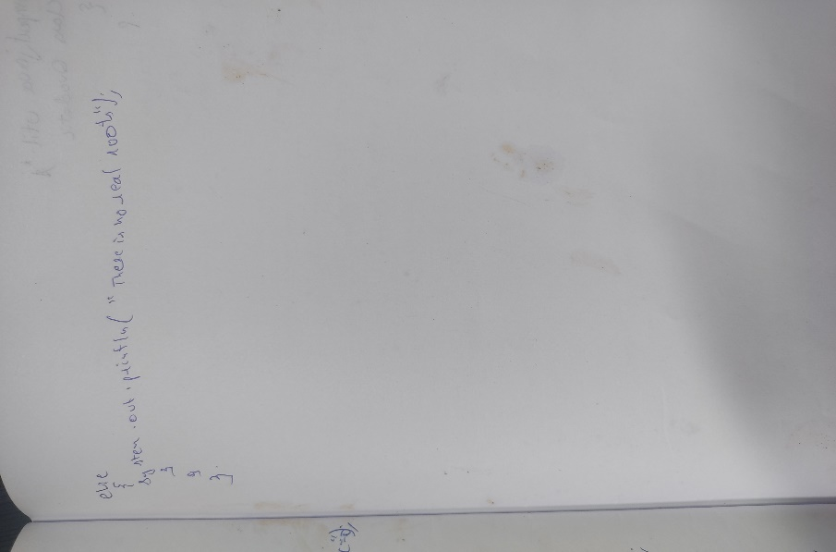

**OUTPUT:**

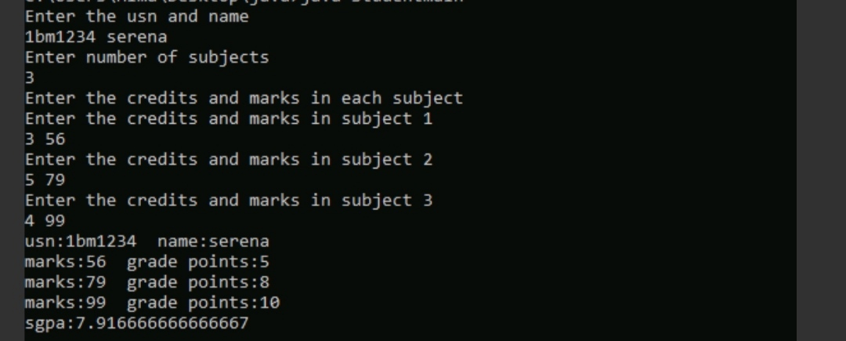

**LAB-3**

**3. Create a class Book which contains four members: name, author, price,**

**num_pages. Include a constructor to set the values for the members. Include**

**methods to set and get the details of the objects. Include a toString( ) methodthat could display the complete details of the book. Develop a Java program tocreate n book objects.**

OBSERVATION:

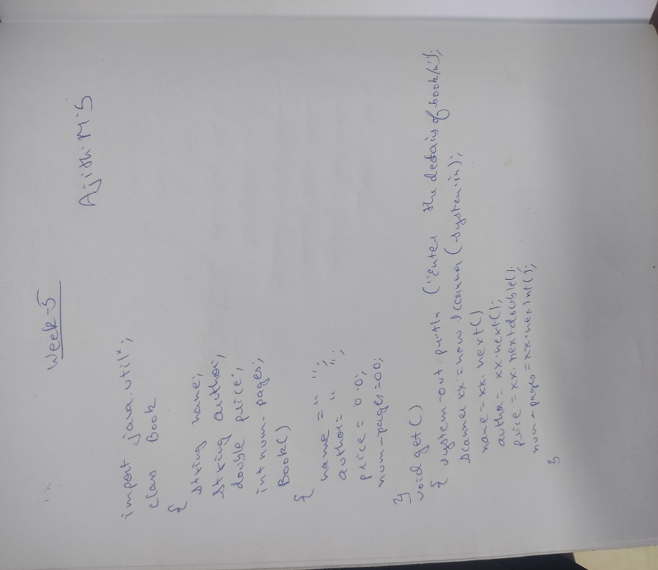 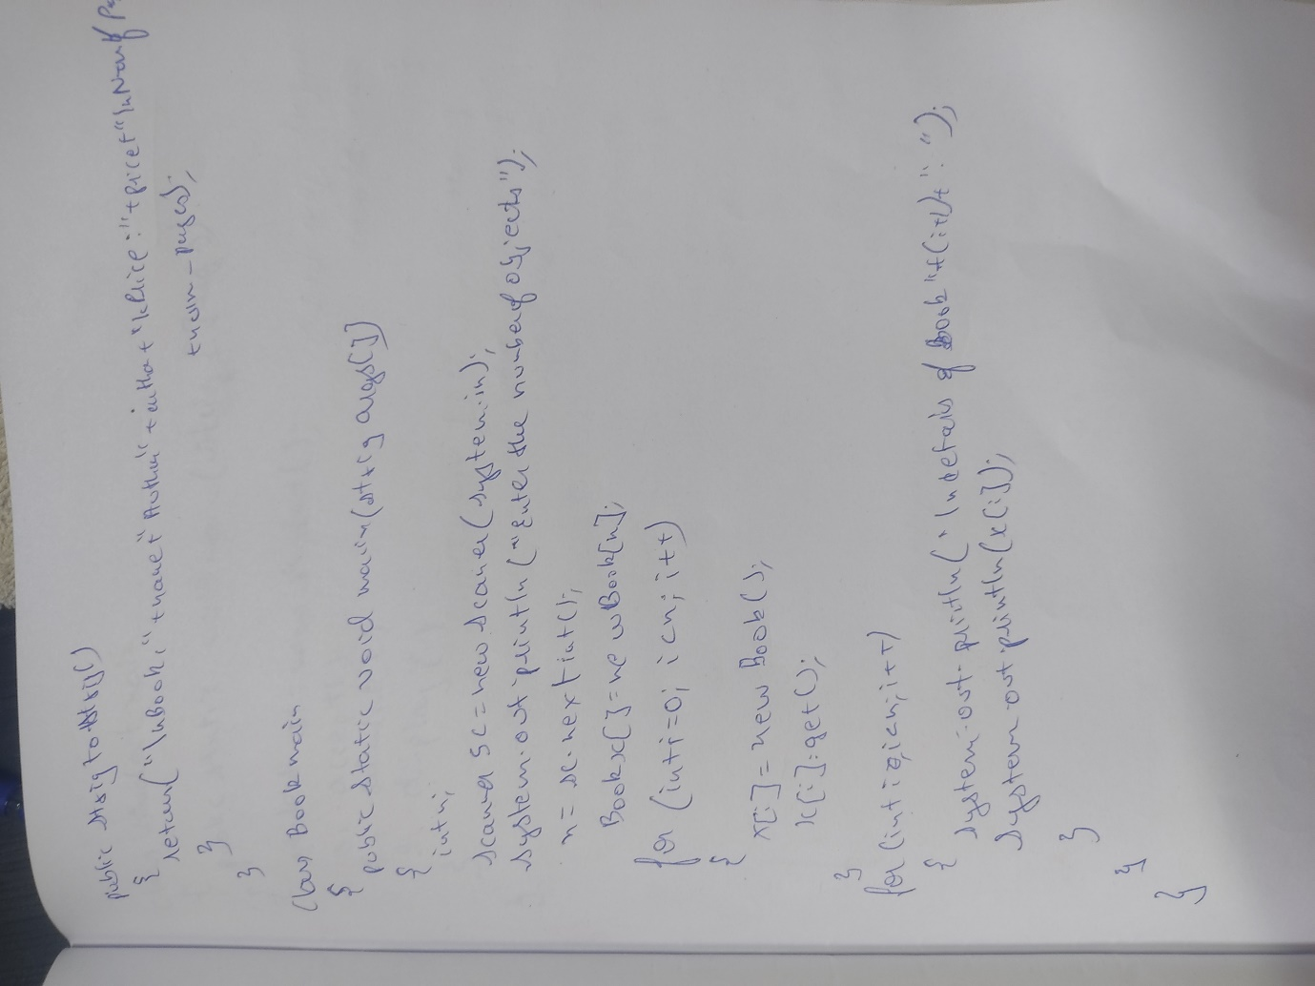

**OUTPUT:**

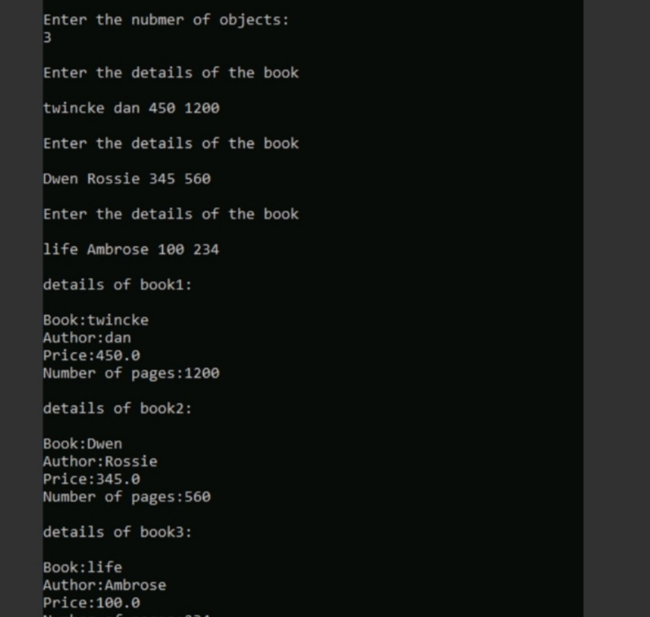

**LAB-4**

**4. Develop a Java program to create a class Student whose variables are usn, name and sem.**

**Derive a class Test from Student to include an array of cie marks of each course and their**

**corresponding credits in another array. Derive a class Exam from Test which includes an**

**array of see marks. Derive a class Result which calculates the grade for each course and the**

**SGPA. Create n student objects and displays all the above details.**

**OBSERVATION**

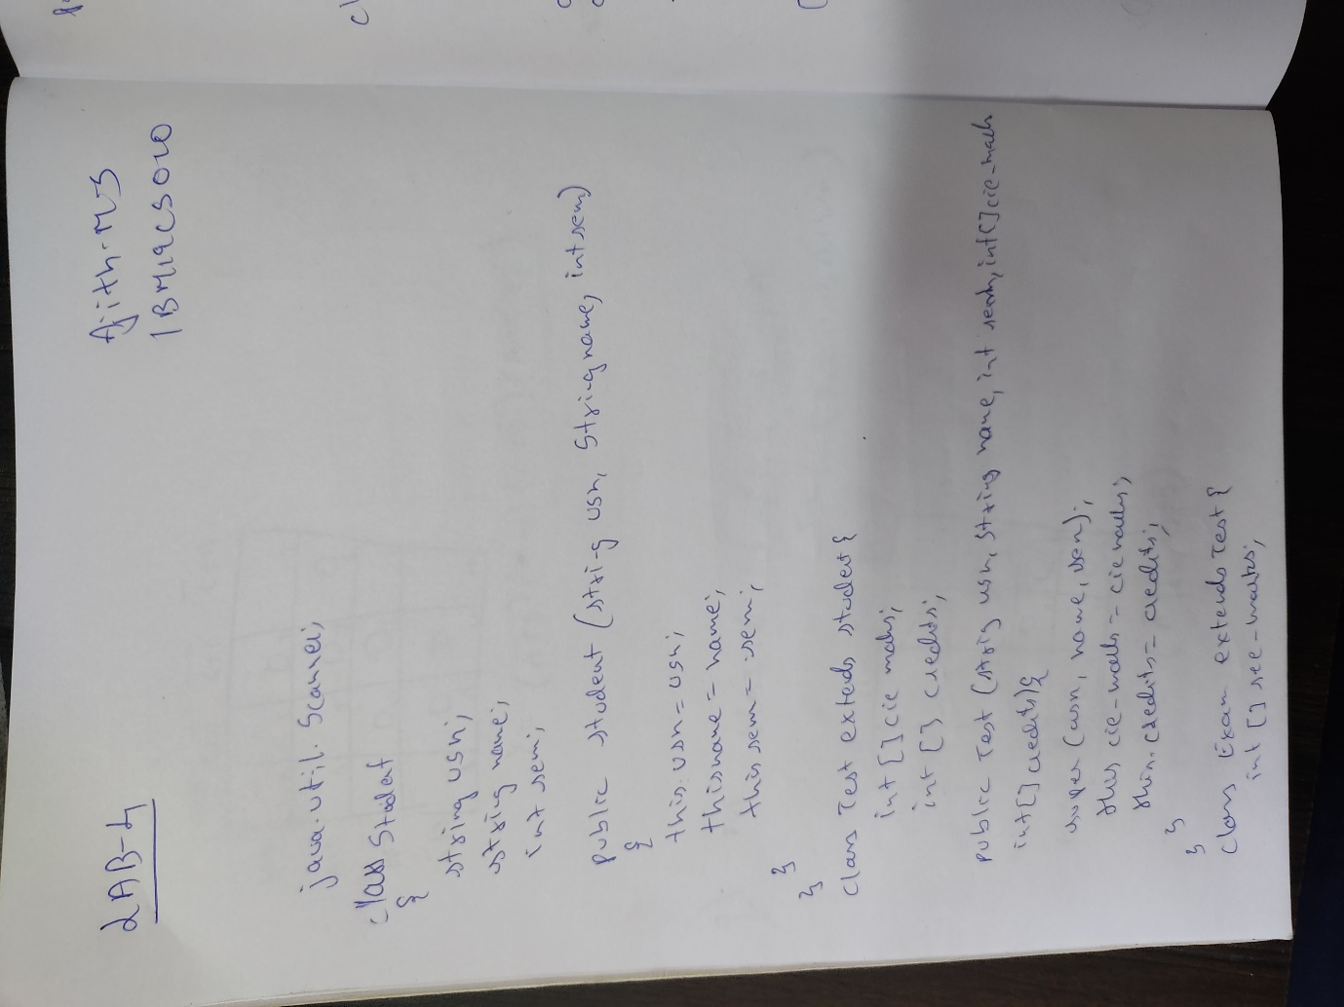

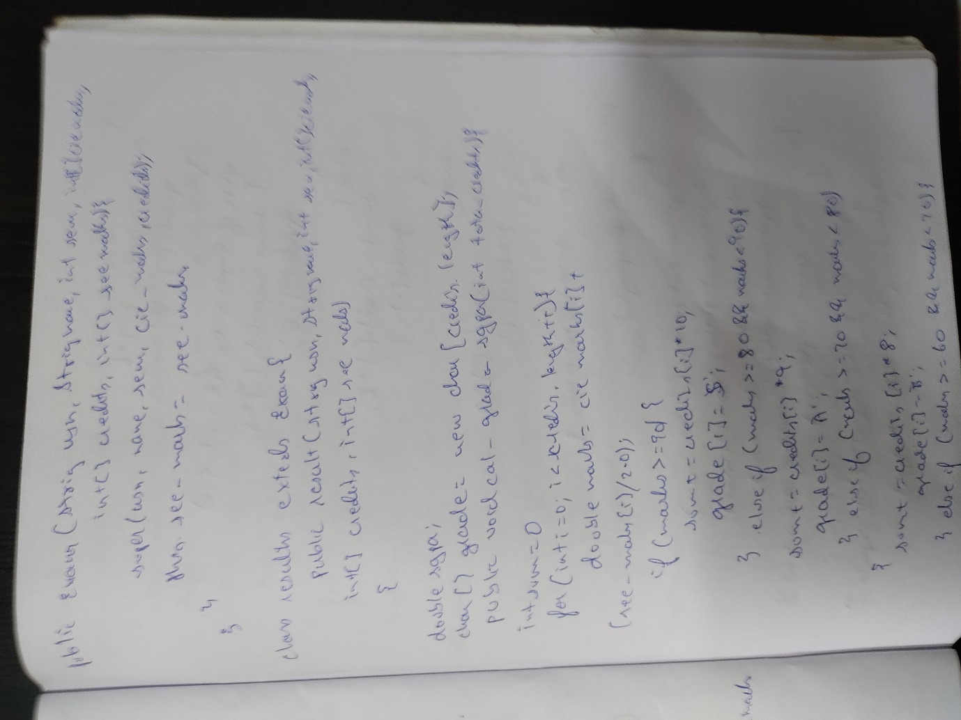

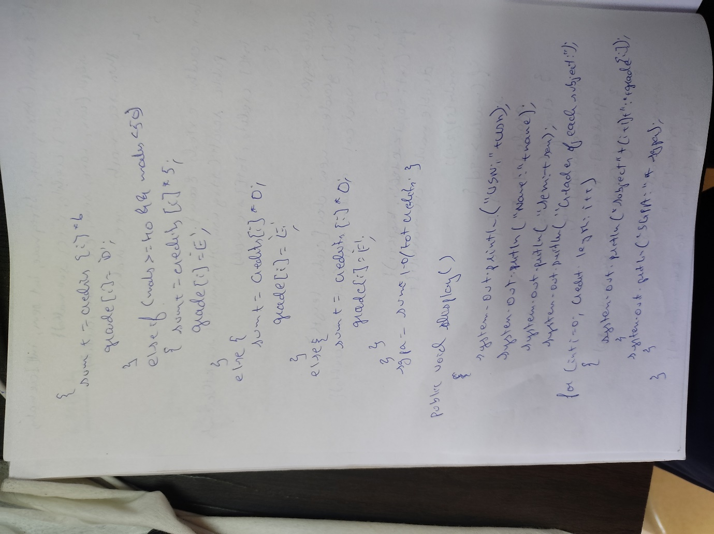

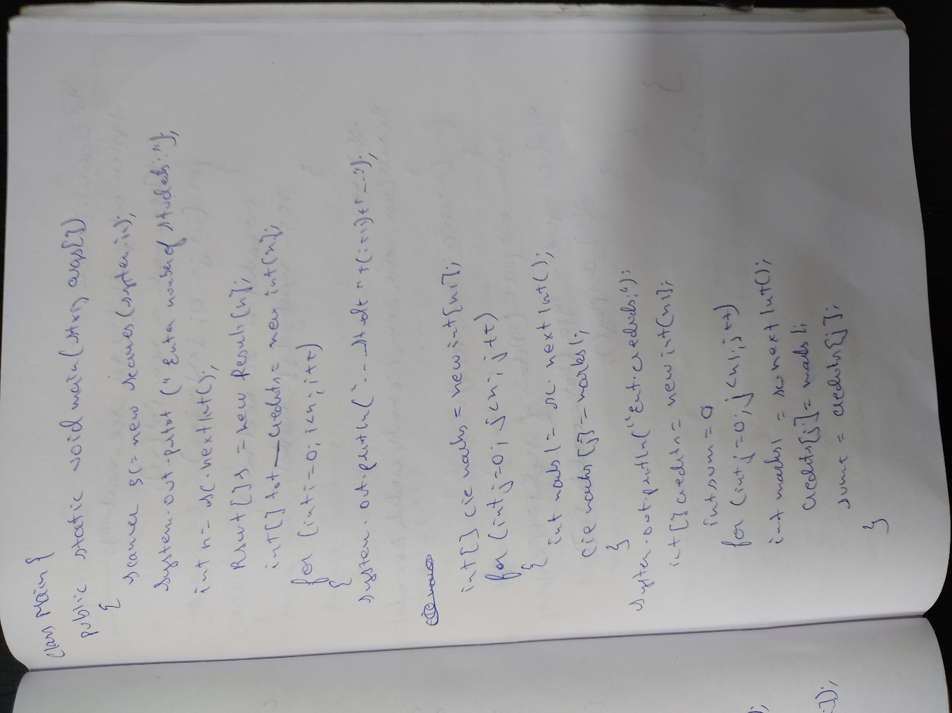

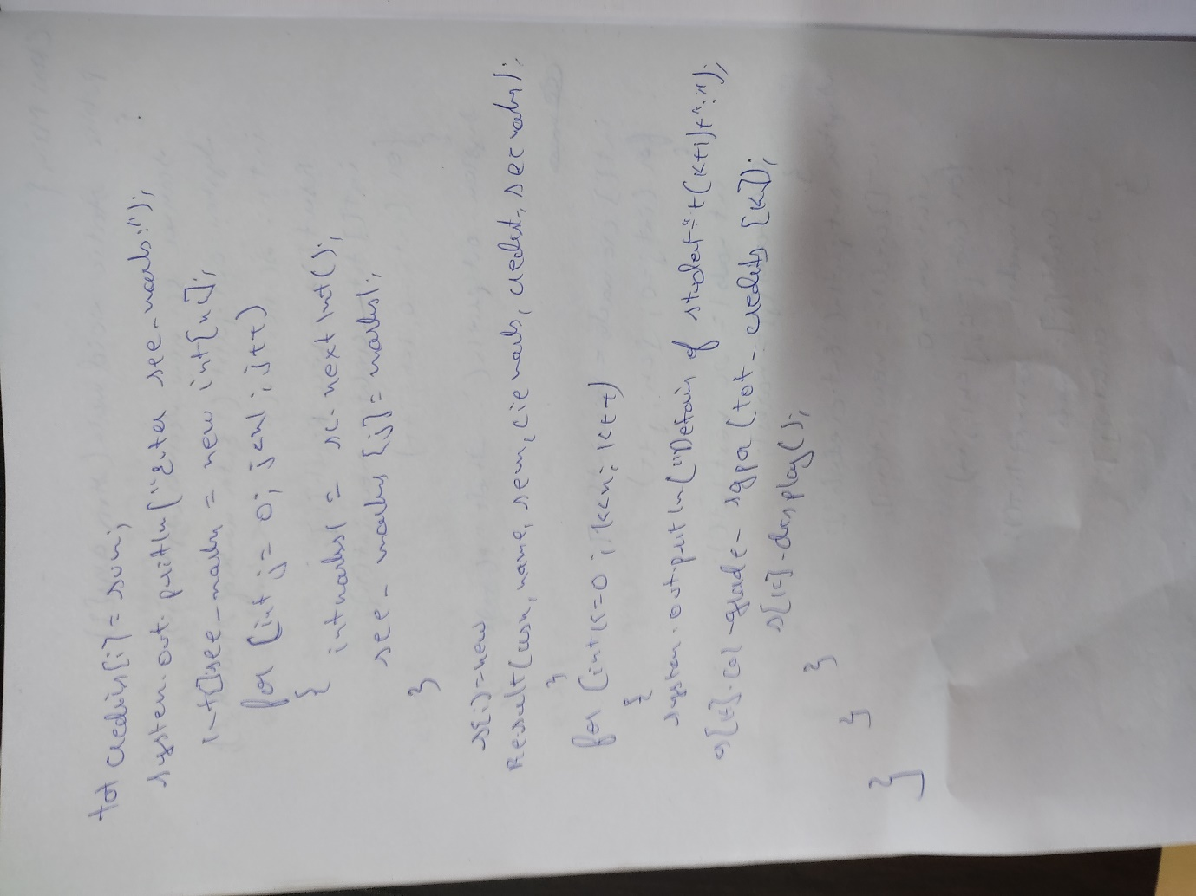

**OUTPUT:**

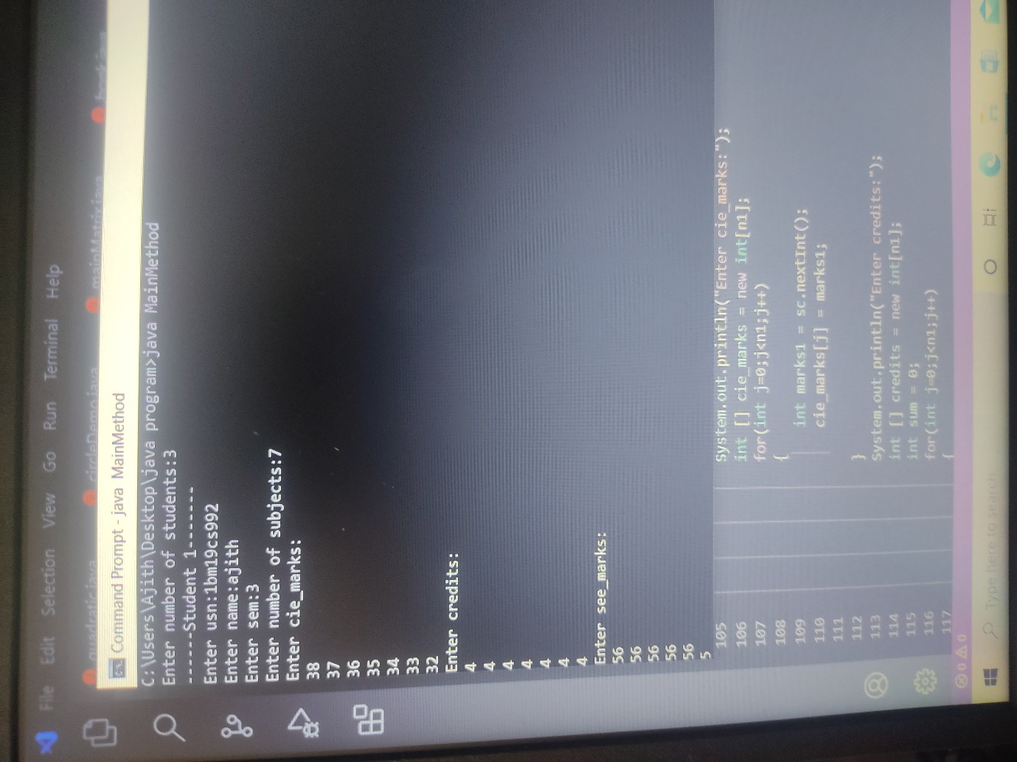

**LAB-5**

5. **Develop a Java program to create an abstract class named Shape that contains two integers and**

**an empty method named printArea( ). Provide three classes named Rectangle, Triangle and**

**Circle such that each one of the classes extends the class Shape. Each one of the classes contain**

**only the method printArea( ) that prints the area of the given shape.**

**Develop a Java program to create a class Bank that maintains two kinds of account for its**

**customers, one called savings account and the other current account. The savings account**

**provides compound interest and withdrawal facilities but no cheque book facility. The current**

**account provides cheque book facility but no interest. Current account holders should also**

**maintain a minimum balance and if the balance falls below this level, a service charge is**

**imposed. Create a class Account that stores customer name, account number and type of**

**account. From this derive the classes Curr-acct and Sav-acct to make them more specific to**

**their requirements. Include the necessary methods in order to achieve the following tasks: •**

**Accept deposit from customer and update the balance. • Display the balance. • Compute and**

**deposit interest • Permit withdrawal and update the balance • Check for the minimum balance,**

**impose penalty if necessary and update the balance**

**OBSERVATION:**

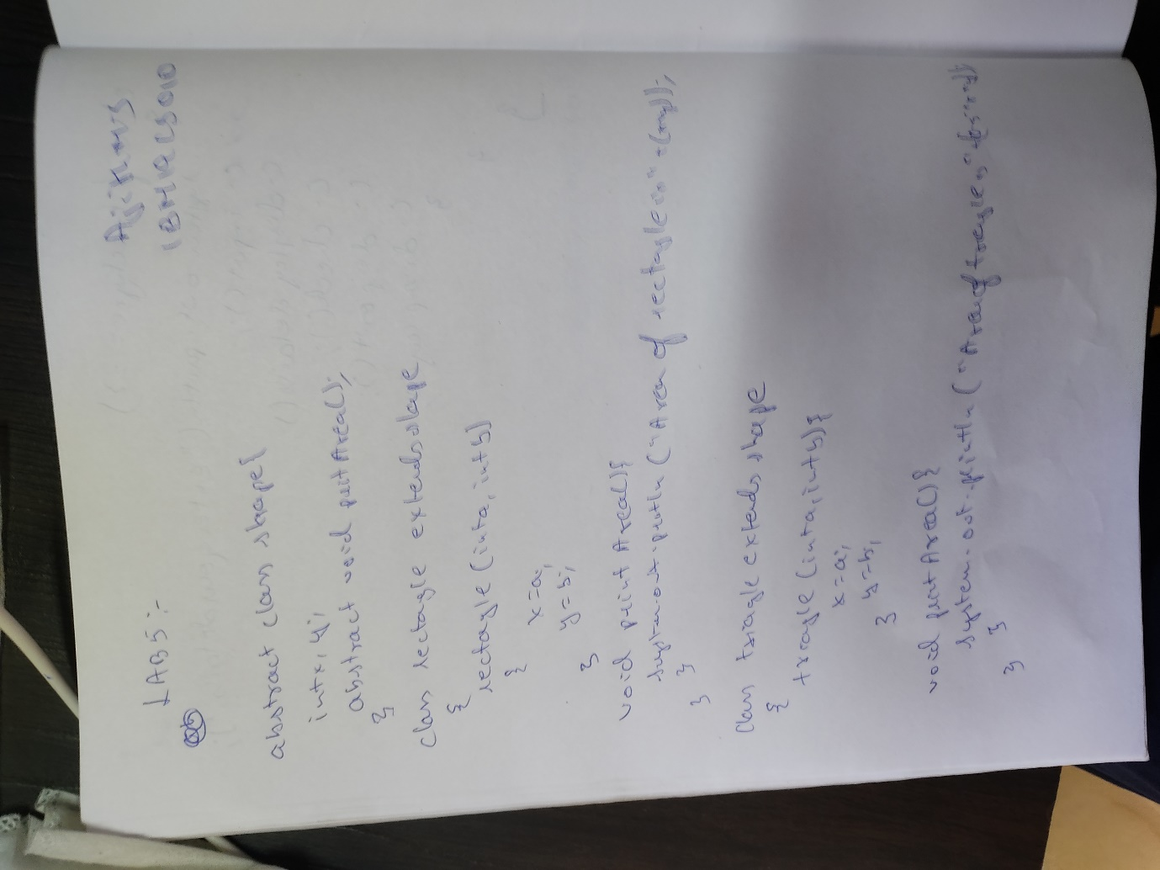

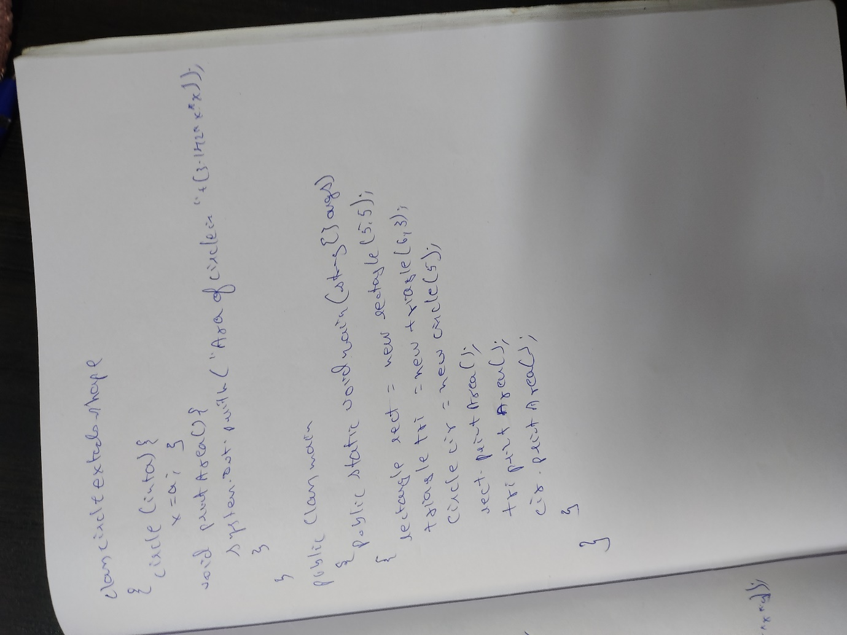

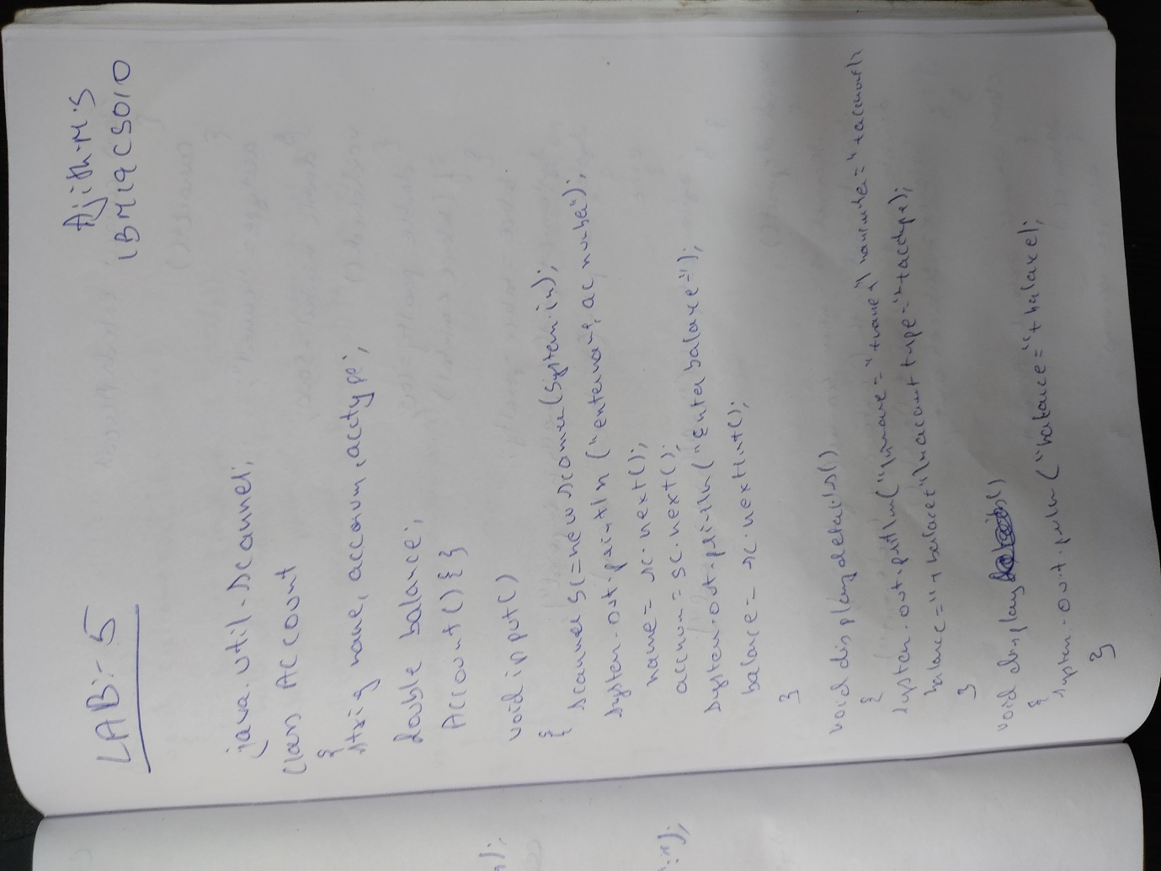 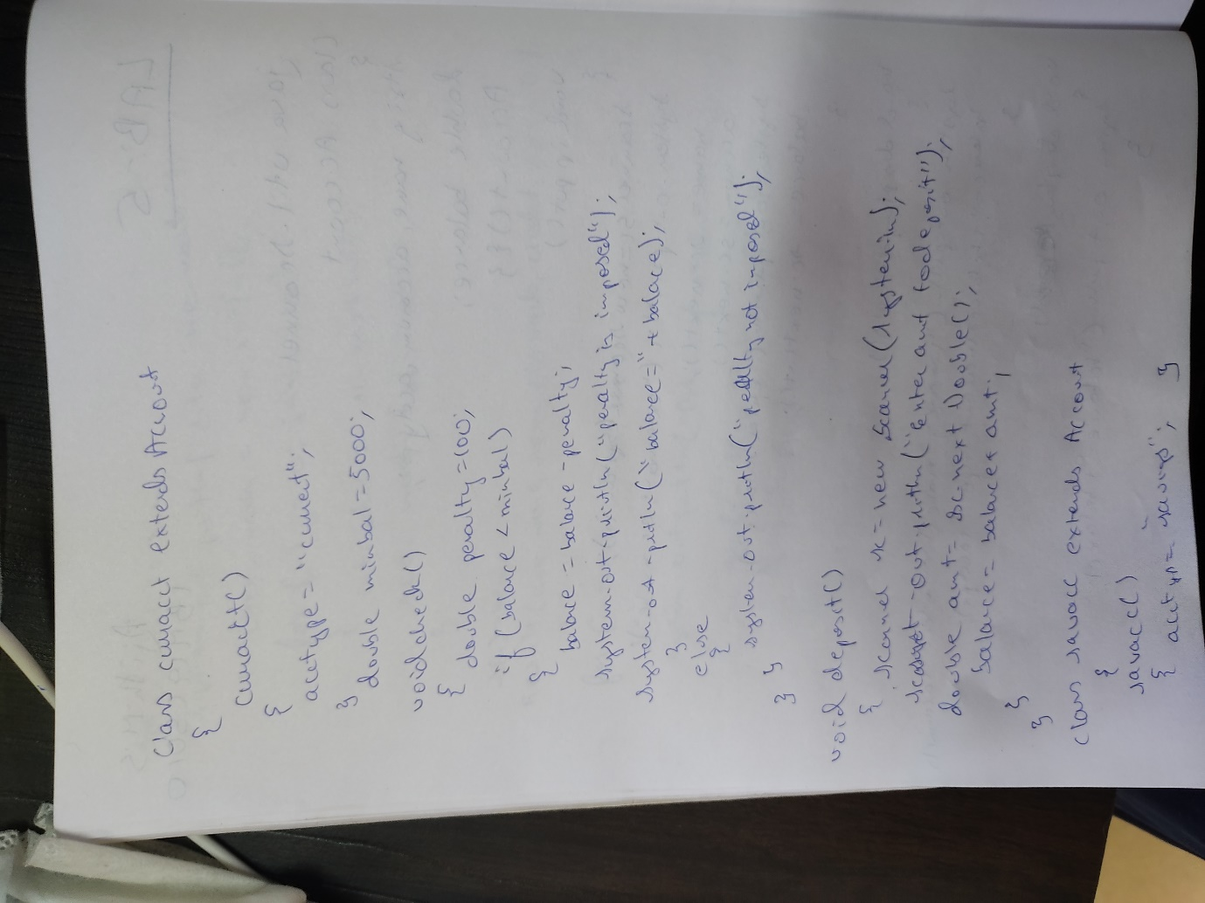 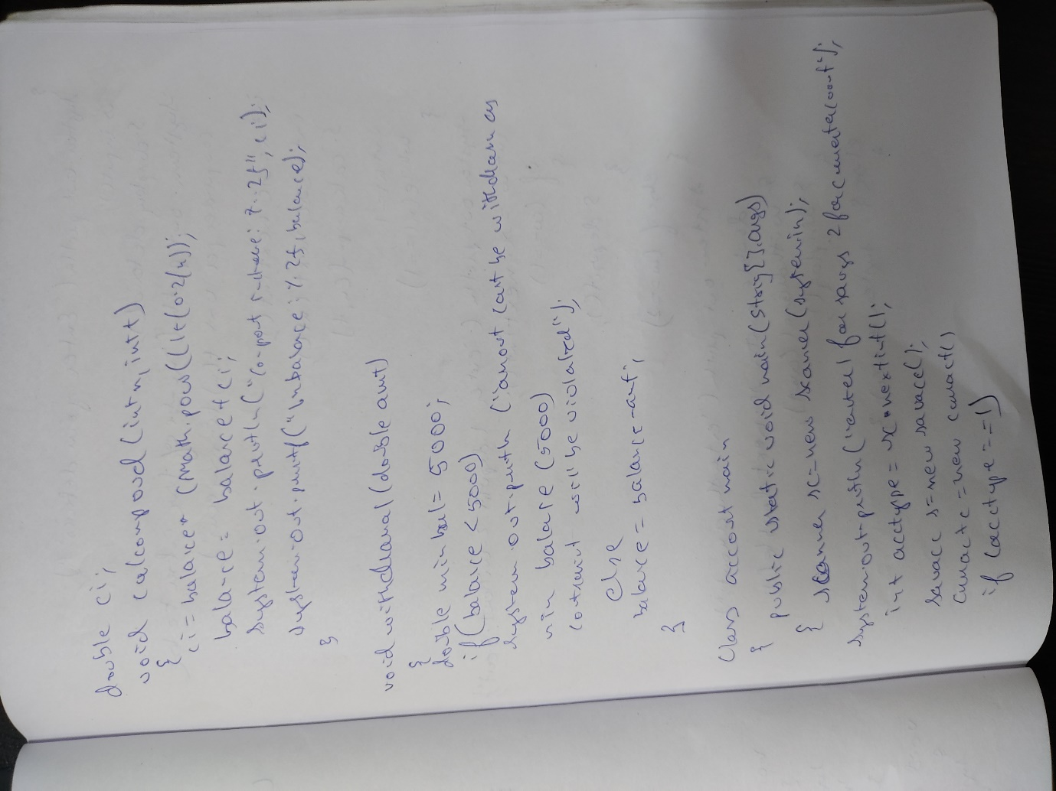 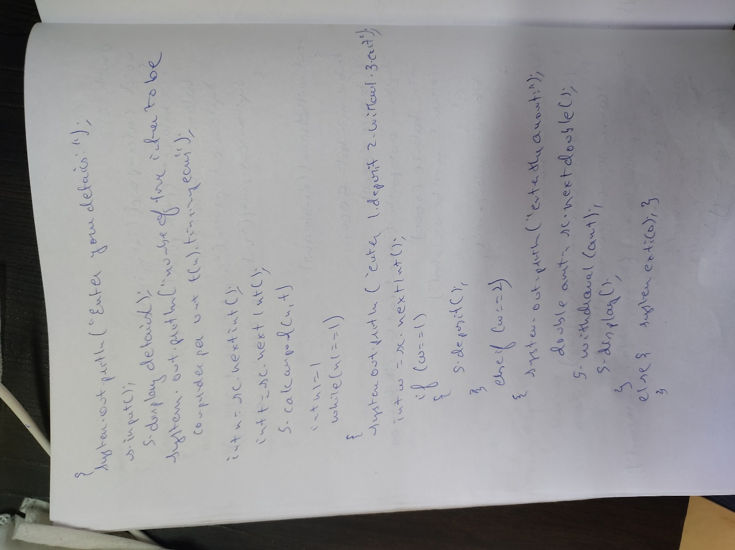

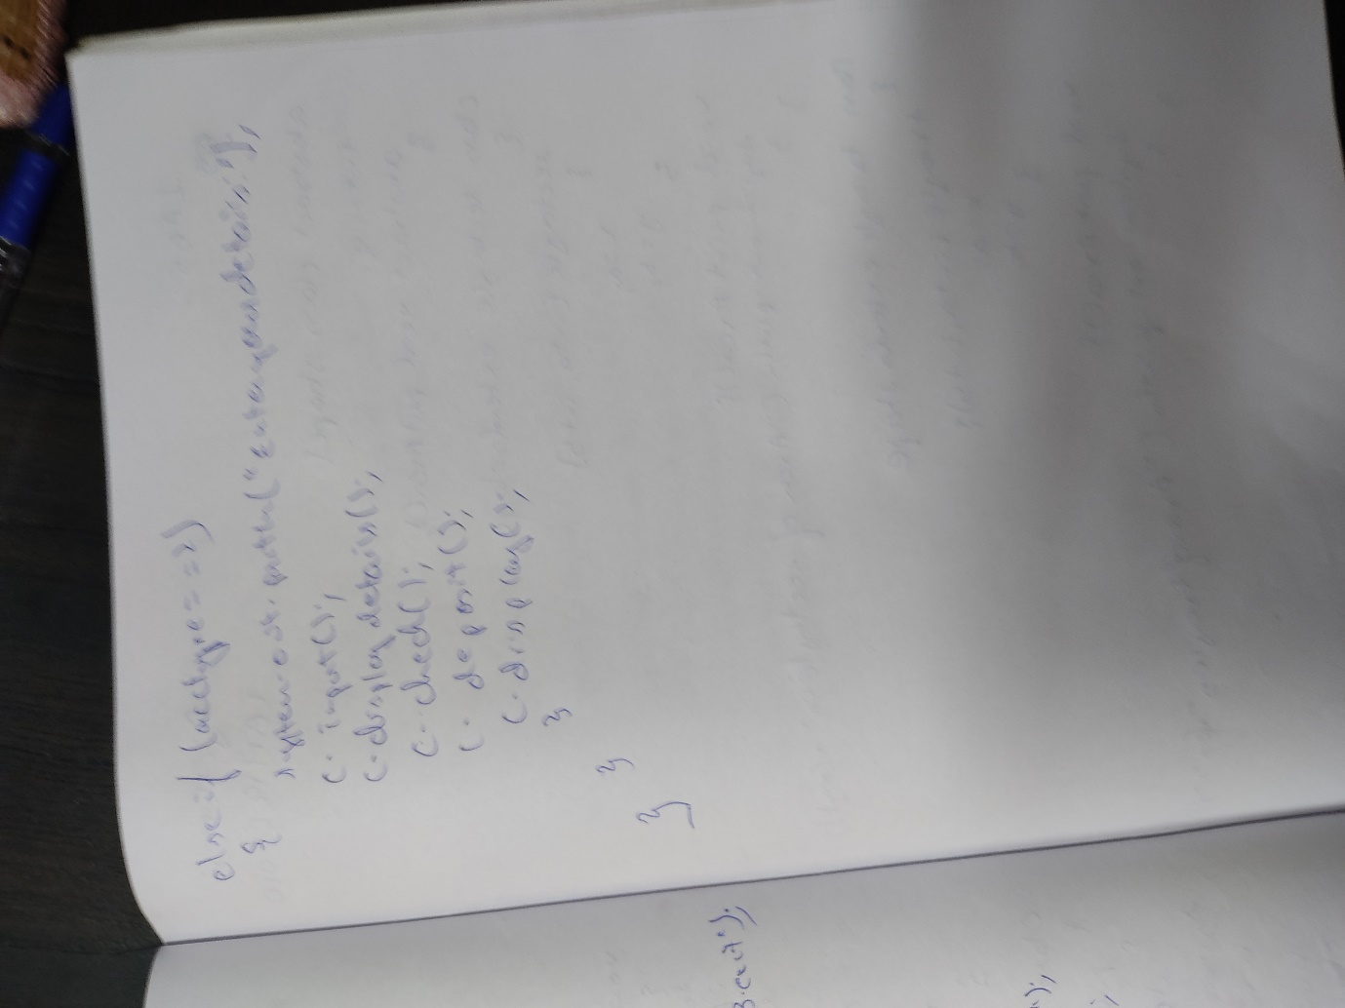

**OUTPUT:**

